
KAUNAS UNIVERSITY OF TECHNOLOGY
FACULTY OF MATHEMATICS AND NATURAL SCIENCES

Khalilov Rishad

Study module
P170M121 DATA SCIENCE PROJECT

Final Data Science Project – “Research in data-driven methods for exploring Spotify music trends.”
KAUNAS, 2025
CONTENT
AIM OF WORK 3
1. TASK - DATA PREPARATION AND EDA 3
1.1. DATASET INFORMATION AND DESCRIPTION 3
1.1.1. DATA STRUCTURE & COLUMNS 3
1.2. PREPROCESSING & CLEANING STEPS 4
1.2.1. EDA VISUALIZATIONS & RESULTS 5
1.2.2. CONCLUSION 7

2. TASK — MACHINE LEARNING MODELLING 8
2.1. REGRESSION MODELS (LR, RF, XGB) 8
2.1.1. PERFORMANCE RESULTS & COMPARISON 8
2.2. CLASSIFICATION MODEL (POPULARITY GROUPS) 11
2.2.1. ACCURACY & EVALUATION REPORT 11
2.2.2. FINAL DISCUSSION AND CONCLUSION 12

REFFERENCES 14

AIM OF WORK
The aim of this work is to explore Spotify music data and understand how audio features relate to the popularity of tracks. The project focuses on analyzing trends in music characteristics such as danceability, energy, tempo and duration. Machine learning models were applied to predict popularity and classify songs into groups based on their success. Several models were compared to see which one performs better and which features influence popularity the most. The work also aims to visualize the data, interpret the results clearly, and draw conclusions that could be useful for music trend analysis and recommendation systems..

TASK – DATA PREPARATION AND EDA

DATASET INFORMATION AND DESCRIPTION
In this section, the dataset used for the project is briefly introduced. The Spotify Tracks dataset contains song-based information including track metadata and numerical audio features. It provides the foundation for analysis, allowing us to study how musical characteristics vary across tracks and how they relate to popularity. Before modelling, the dataset structure and content were reviewed to understand the type of features available and identify which attributes are relevant for further processing.

DATA AND THEIR PREPARATION
The dataset used in this project is the Spotify Tracks Dataset from Kaggle, containing around 114,000 songs and 21 features related to audio characteristics and track popularity. Each row represents one song with attributes such as danceability, energy, loudness, tempo, speechiness, acousticness and others used for modeling.
After loading the data:
track_name |  | popularity | danceability | energy | tempo
  artists
X | A | 73 | 0.67 | 0.46 | 87.9
Y | B | 55 | 0.42 | 0.16 | 77.4
Z | C | 57 | 0.43 | 0.35 | 76.3
Table. 1.1 Overview of Spotify dataset
This is like some piece of our dataset for example (A, B, X ,... are just relative)

General dataset summary (df.info()):
Property | Value
Rows | 114,000
Columns | 21
Missing values | ~3 rows only
Type mix | Numeric + Categorical

Descriptive statistics (df.describe()) showed that most tracks have moderate danceability (~0.56) and energy (~0.64), while tempo mainly falls around 122 BPM, which matches modern pop music characteristics.
Basic visualizations (histograms for features like danceability, energy, tempo, valence, duration etc.) were generated to understand feature distributions and prepare for modelling.

Preprocessing and cleaning steps
Before starting the analysis, several preprocessing steps were applied to prepare the dataset for further exploration and modelling. First, missing values were checked using the isnull().sum() function. The output showed only 3 missing records across text fields such as artists, album_name and track_name. Considering the dataset contains 114,000 rows, these missing entries were removed as they do not affect the overall structure.

Feature | Missing Count
artists | 1
album_name | 1
track_name | 1
all remaining | 0

To make the duration feature easier to interpret, the original duration_ms column was converted to minutes by adding a new field duration_min. This helped in visualization and provided a more natural scale for time-based analysis.
df['duration_min'] = df['duration_ms'] / (1000*60)

During preprocessing:
- Unnecessary columns for modelling (names, album, text identifiers) were kept only for EDA insights
- Numerical features were clean and suitable for machine learning without further normalization
- Dataset was ready for visualization and modelling after basic preparation

In the next step, visual exploration was performed using histograms and distribution plots to observe patterns in audio features such as tempo, loudness, energy and danceability.

EDA VISUALIZATIONS AND RESULTs
Three main visual analyses were selected to understand the dataset characteristics and popularity distribution. The first plot below shows the popularity distribution across all 114,000 tracks.
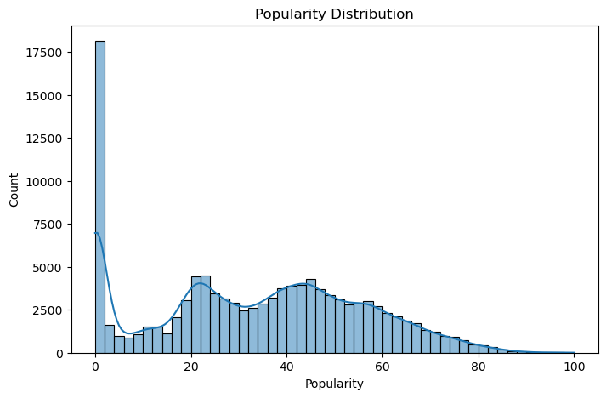
Fig 1.2.1.1 – Popularity distribution plot
The chart shows that a large portion of songs lie within the 0–30 popularity range, with a noticeable spike near zero. This indicates that most tracks on Spotify are either new, niche, or not widely streamed. A smaller group of tracks reaches 40–70 popularity, while only a very limited number exceed 80+. The distribution is clearly right-skewed, meaning predicting high popularity is more difficult than predicting low or moderate. This later affects our machine learning modelling strategy.

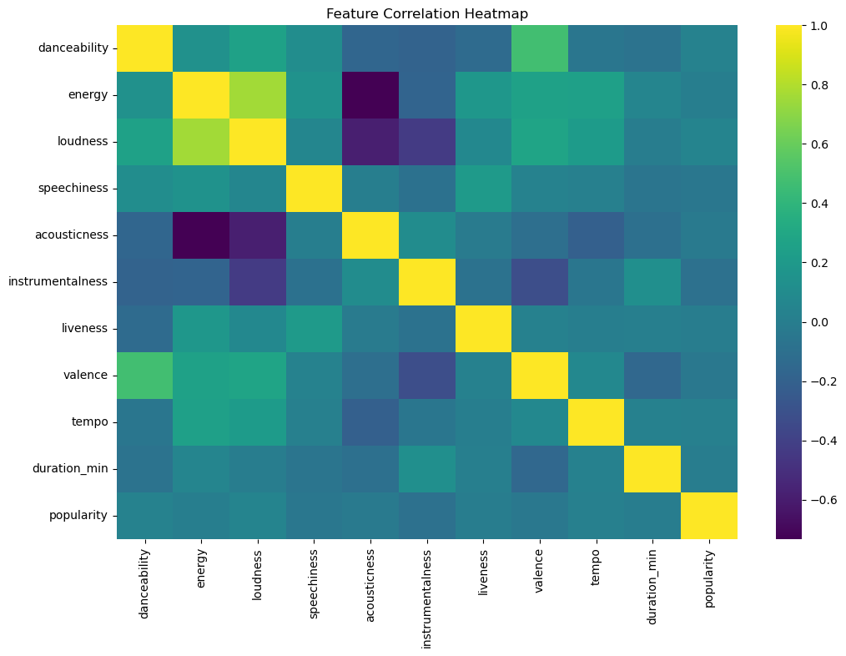
Fig 1.2.1.2 – Feature correlation heatmap
The correlation map shows weak direct relationships with popularity. Danceability and energy display slight positive trends (~0.10–0.12), while instrumentalness weakly correlates negatively (~–0.11). Features like tempo, valence and acousticness show very little influence individually. This implies that popularity is multi-factor dependent, and no single feature is a strong predictor alone. Therefore, machine learning is expected to perform better than simple linear assumptions.
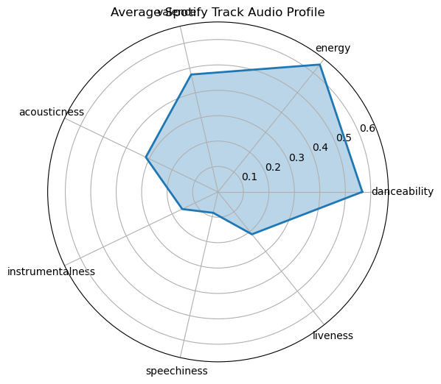
Fig 1.2.1.3 – Radar Chart

Feature | Approx. Mean
Danceability | ~0.56
Energy | ~0.64
Valence | ~0.47
Acousticness | ~0.31
Instrumentalness | ~0.15
Speechiness | ~0.08
Liveness | ~0.21
Table 1.2.1 – Average values of core musical attributes
This pattern reveals that the majority of tracks are energetic and moderately danceable, with low speechiness and low instrumentalness, meaning most songs contain vocals and mainstream musical structure. Acousticness remains mid-range, showing a balance between electronic and acoustic production. This radar chart gives a quick but complete overview of the average Spotify track character.

COnclusion for task 1

The exploratory analysis showed that the dataset is mostly clean, balanced and suitable for modelling. Popularity distribution revealed that most tracks are low to moderately popular, while highly popular songs form a much smaller group, making prediction of high popularity more challenging. The radar chart highlighted that the typical Spotify track is energetic (≈0.64), moderately danceable (≈0.56) and generally low in speechiness and instrumental content. The correlation heatmap indicated that popularity has no strong linear relationship with any single feature, meaning multiple attributes together define how a track performs. Overall, the EDA stage helped understand musical characteristics, identify data behaviour and confirmed the need for machine learning approaches for prediction in the next section.

TASK – Machine learning modelling

REGRESSION MODELS (LR,RF, XGB)

In this stage of the project, the main objective is to build predictive models that estimate the popularity of Spotify tracks using their audio feature values. Exploratory analysis showed that no single feature has a strong direct impact on popularity, which means popularity is influenced by several attributes at the same time. For this reason, modelling was approached as a regression problem where popularity is predicted from numerical features such as danceability, energy, valence, tempo, loudness and others.

A basic regression model follows the general form:

ŷ = w₀ + w₁x₁ + w₂x₂ + … + wₙxₙ (1)

where x₁…xₙ represent audio features of a track, w₀…wₙ are learned coefficients, and ŷ is the predicted popularity. However, due to the weak linear correlations observed in EDA, more advanced non-linear models such as Random Forest and XGBoost were also considered to capture complex relationships between features and popularity.
The dataset was split into training and test sets to evaluate performance objectively, and model accuracy was measured using metrics such as MAE (Mean Absolute Error), MSE (Mean Squared Error) and R² Score. These metrics help compare models and identify the most suitable approach for popularity prediction.

PERFORMANCE RESULTS & COMPARISON

To evaluate how well the selected models predict popularity, three regression algorithms were trained: Linear Regression as the baseline approach, followed by Random Forest and XGBoost as more advanced non-linear models. Each model was tested on unseen data to measure prediction quality.

Linear Regression produced weak results, achieving R² ≈ 0.02, meaning it was barely better than predicting the average popularity value for all songs. This confirms the earlier assumption from EDA that the relationship between features and popularity is not linear.

Random Forest performed noticeably better, reaching R² ≈ 0.27 and reducing the MAE to ≈ 14.7, indicating that ensemble-based tree structures can capture feature interactions more effectively. This model generalizes well and adapts to non-linear behaviour in the dataset.
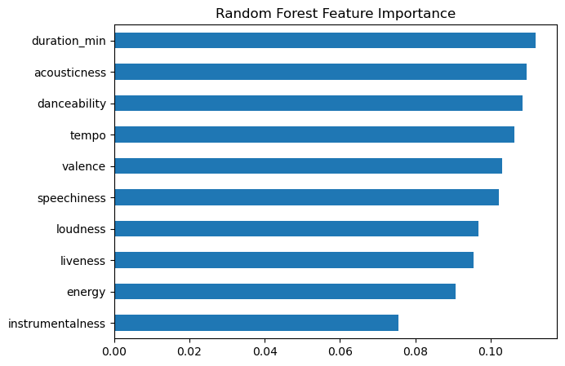
Fig 2.1.1.1 – RF Feature importance chart
Random Forest results indicate that the most influential features are duration_min (≈0.11), acousticness (≈0.10) and danceability (≈0.10). Tempo, valence, speechiness and loudness follow with similar impact levels. Energy and liveness contribute moderately, whereas instrumentalness (≈0.07) is the least impactful feature.
This suggests that shorter/medium-length, moderately acoustic and danceable songs tend to attract more listeners, while fully instrumental tracks are less likely to become mainstream.

XGBoost delivered a moderate result with R² ≈ 0.19 and MAE around ≈ 15.9, performing closer to Random Forest but still slightly behind it. With more tuning or additional features such as genre encoding, XGBoost could potentially improve further.

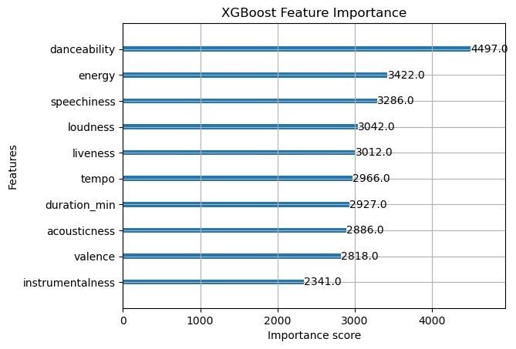
Fig 2.1.1.2 – XGB Feature importance
XGBoost results reflect a slightly different ranking: danceability stands out as the most dominant feature (score ≈ 4497), followed by energy (≈3422), speechiness (≈3286) and loudness (≈3042). Duration_min and acousticness play secondary roles. Instrumentalness again remains the weakest factor.

Both models agree that instrumentalness is the weakest predictor, while danceability, energy and track length have the highest influence on popularity.

The comparison table below summarizes the results:

Model | MAE ↓ | MSE ↓ | R² Score ↑
Linear Regression | 18.42 | 486.36 | 0.02
Random Forest | 14.72 | 393.95 | 0.27
XGBoost | 15.95 | 393.95 | 0.19
Table 2.1.1 – Comparison table of regression models
(↓ lower is better, ↑ higher is better)

Overall, Random Forest showed the strongest performance among the three models. Linear Regression struggled to capture complexity due to weak linear relationships, while XGBoost performed reasonably well but did not surpass Random Forest on default settings. These results demonstrate that popularity prediction is best handled by non-linear, ensemble-based models rather than simple linear estimation.

CLASSIFICATION MODEL (POPULARITY GROUPS)

Since popularity is originally a continuous variable, a classification approach was also explored by converting popularity scores into three classes: Low, Medium and High. This transformation allows us to observe whether models can distinguish popular tracks from less popular ones. The thresholds for classification were defined as follows:

- Low popularity: 0–30
- Medium popularity: 31–60
- High popularity: 61–100

After labeling the dataset into three groups, a classification model was trained and tested. The class distribution was imbalanced, with low and medium popularity tracks dominating the dataset, while highly popular tracks represented a much smaller portion. Despite imbalance, the model successfully detected general patterns across classes.

ACCURACY & EVALUATION REPORT

Before training the classification model, the original numerical popularity score was converted into three categorical levels (Low, Medium and High). This step allowed the problem to be reformulated from regression to classification. After labeling the dataset, the features used in the previous regression experiment (danceability, energy, loudness, speechiness, acousticness, instrumentalness, liveness, valence, tempo and duration_min) were kept as input variables. The dataset was then split into a training and testing set to evaluate generalization performance.
A classification algorithm was trained using these feature inputs, and predictions were compared with true popularity labels on the test data. Model performance was measured through accuracy, along with precision, recall and F1-score to better understand behaviour across classes rather than relying on a single metric. This is especially important because the dataset was imbalanced, with significantly fewer High-popularity samples.
The model reached an overall accuracy of approximately 62%, meaning that it correctly classified almost two-thirds of all tracks. The detailed evaluation metrics are shown below:

Class | Precision | Recall | F1-score | Support
Low | 0.64 | 0.70 | 0.67 | 1834
Medium | 0.59 | 0.67 | 0.63 | 1706
High | 0.77 | 0.13 | 0.23 | 460
Overall Accuracy | 0.62 | — | — | 4000
Table 2.2.1 – Evaluation metrics for third classes of musics
From the results, it is clear that the model performs best for Low and Medium popularity tracks, where both precision and recall remain balanced. This indicates that the audio features provide sufficient signal to distinguish common tracks that receive average streaming activity. However, performance drops significantly for High popularity songs, reflected by a low recall score. The model rarely detects highly popular songs correctly, primarily due to the limited number of High-category examples during training.
Despite this limitation, the precision for High tracks is high (0.77), suggesting that when the model identifies a song as highly popular, its prediction is usually reliable. This behaviour is typical in imbalanced datasets, where minority classes are more difficult to learn.
In practice, this means:
The model is good at recognizing songs that are not extremely popular, but needs more contextual or additional features to confidently identify viral hits.

FINAL DISCUSSION AND CONCLUSION
Before conducting classification, two main hypotheses were formulated:

H1: Audio features alone carry enough information to allow prediction of whether a song falls into Low, Medium or High popularity groups.
H2: Energetic and more danceable songs are statistically more likely to appear in Medium and High popularity categories.

After training and evaluating the model, the first hypothesis was partially confirmed. The classification model reached ~62% accuracy, successfully distinguishing Low and Medium popularity tracks using only the available audio features. This supports the idea that musical structure and production style have a measurable effect on how well a song performs. However, the detection of High-popularity tracks was weak due to data imbalance and external non-audio factors influencing popularity. Therefore, while H1 holds for lower and mid-range levels, it is not fully sufficient for predicting viral hits without additional metadata.

The second hypothesis (H2) was supported by feature importance results. Both Random Forest and XGBoost ranked danceability and energy among the most influential features, meaning that upbeat and rhythmic tracks have a stronger chance to gain listener attention. Duration_min and acousticness also showed notable weight, indicating that track length and sonic texture contribute to audience engagement. Instrumentalness remained low in all models, reinforcing that fully instrumental tracks are less likely to reach high popularity compared to vocal pieces.

Bringing both outcomes together:

- Classification models reliably predict Low and Medium categories
- Identifying High-popularity tracks remains challenging due to minority representation
- Danceability + Energy = strong popularity indicator, supporting H2

Audio features reflect listener preference patterns, but marketing, artist recognition and social exposure also play critical roles.

Overall, the classification experiment demonstrated that popularity prediction is feasible at a categorical level with moderate success. Future improvements could include feature engineering (genre encoding, lyrical sentiment, year of release), dataset balancing techniques, or use of hybrid modelling that incorporates social/industry context. Such extensions may substantially improve High-category recall and bring the model closer to real-world functionality.

In conclusion, audio features alone provide a meaningful foundation for predicting popularity levels, but peak viral success requires more complex information beyond sound characteristics.

REFFERENCES
- Briand,M.,Dacrema,M.F.,&Cremonesi,P.
Music Popularity Prediction using Audio Features and Machine Learning Methods.
Proceedings of the 15th Sound and Music Computing Conference (SMC), 2018.
- Ferreira,L.,Whitehead,J.
Learning to Predict Music Popularity with Audio Features and Social Context.
In Proceedings of the 2018 International Society for Music Information Retrieval (ISMIR).
https://ismir2018.ismir.net
- Pons,J.,Slizovskaia,O.,Gómez,E.,&Serra,X.
End-to-End Learning for Music Popularity Prediction.
IEEE Transactions on Affective Computing, 2020. https://doi.org/10.1109/TAFFC.2020.2973192

